Literature Review

A literature review provides a general overview of the existing research on a particular topic. It aims to summarize, synthesize, and sometimes critique studies without following a strict methodology. It is often used to provide background or context for research. A systematic review is a kind of literature review to address a specific, focused research question using a rigorous and predefined methodology. It usually involves providing a comprehensive, unbiased summary of the evidence.

How to do a search for literature review?

1. First of all identify some relevant keywords (You might have to improve these keywords by try and error and look for the repetitive words in the abstract section of some of the relevant papers, you can use AND and OR operators to find the best results)
2. search some of these resources: Scopus search, Google search, University's Library search filter for the past 5 years
3. Read the titles and then abstract to identify relevant and irrelevant articles that come up in the search
4. Check the number of citations and where the article published to identify the most reliable articles
5. You can install referencing software such as Mendeley (Swinburne has a subscription) and their Google Chrome extension to download articles on spot and save them to your reference library. Alternatively you can save to keep the articles you have found or create a lists of them online
6. Use software such as VOS Viewer with your list of articles to generate a graphical view, helping you identify the most important papers and the chronological timeline of the research

**To read less and be more efficient**

Start by searching reference databases and selecting the most relevant papers based on their titles. If necessary, read the abstracts to further refine your selection.

Once you've chosen some papers, the most efficient way to read them is to focus on the last paragraph of the introduction, the methods section, and the conclusion. When reviewing the methods, you don’t need to read every paragraph thoroughly—simply reading the first sentence of each paragraph will give you an idea of what it's about.

**To identify reputable journals and conference**s

Search for their names in the [Core Conference ranking](https://www.core.edu.au/conference-portal) for conferences and [Scimago](https://www.scimagojr.com/) for journals. The highest ranked conferences are A*, followed by A and so on. For journals the top ranked ones are Q1 followed by Q2.

Any journal with an impact factor of less than 2 is not considered reputable.

**A systematic review** is a structured and comprehensive method of synthesizing research evidence on a specific question or topic. Key Features of a Systematic Review:

1. **Clear Research Question**
2. **Comprehensive Search**
3. **Inclusion and Exclusion Criteria**
4. **Critical Appraisal**: Each included study is assessed for quality and risk of bias to ensure the findings are reliable.
5. **Data Synthesis**: The findings of the included studies are systematically analyzed and, if appropriate, combined using meta-analysis (a statistical technique to aggregate results).
6. **Transparency**: process, including search strategies, criteria for inclusion, and methods for appraising studies, is documented

PRISMA (Preferred Reporting Items for Systematic Reviews and Meta-Analyses) is a widely recognized set of guidelines designed to improve the reporting and transparency of systematic reviews and meta-analyses. It provides a standardized framework that helps authors ensure their reviews are comprehensive, transparent, and replicable. It has a checklist with 27 items that guide authors in reporting the key aspects of a systematic review or meta-analysis. There is also a flowchart that illustrates the process of study selection, from the identification of studies through screening, eligibility, and final inclusion in the review.

These are some of the 27 items:

**Title**: Identify the report as a systematic review, meta-analysis, or both.

**Structured summary**: Provide a structured summary including background, objectives, data sources, study eligibility criteria, participants, interventions, study appraisal and synthesis methods, results, limitations, conclusions, and implications of key findings.

**Rationale**: Describe the rationale for the review in the context of what is already known.

**Objectives**: Provide an explicit statement of the questions being addressed with reference to participants, interventions, comparisons, outcomes

**Protocol and registration**: Indicate if a review protocol exists, and if and where it can be accessed (e.g., a web address), and provide registration information including registration number.

**Eligibility criteria**: Specify study characteristics (e.g., PICOS, length of follow-up) and report characteristics (e.g., years considered, language, publication status) used as criteria for eligibility, giving rationale.

* + **Information sources**: Describe all information sources (e.g., databases with dates of coverage, contact with study authors to identify additional studies) in the search and date last searched.
  + **Search strategy**: Present the full electronic search strategy for at least one database, including any limits used, such that it could be repeated.
  + **Study selection**: State the process for selecting studies (e.g., screening, eligibility, included in systematic review, and, if applicable, included in the meta-analysis).
  + **Data collection process**: Describe the method of data extraction from reports (e.g., piloted forms, independently, in duplicate) and any processes for obtaining and confirming data from investigators.
  + **Data items**: List and define all variables for which data were sought (e.g., PICOS, funding sources) and any assumptions and simplifications made.
  + **Risk of bias in individual studies**: Describe methods used for assessing the risk of bias of individual studies (including specification of whether this was done at the study or outcome level), and how this information is to be used in any data synthesis.

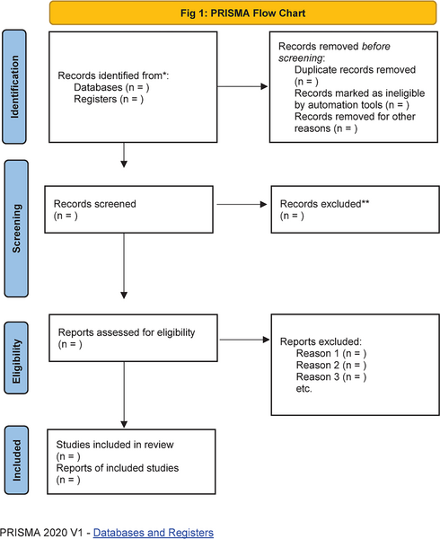

Ref: <https://journals.plos.org/plosone/article/figures?id=10.1371/journal.pone.0290701>

**A Scoping review** is a type of literature review that aims to map the existing research on a broad topic, clarify key concepts, and identify gaps in knowledge. Unlike a systematic review, which focuses on a specific research question and often synthesizes evidence to inform decision-making, a scoping review is more exploratory and descriptive in nature.

Key Features of a Scoping Review:

1. **Broad Research Question**
2. **Comprehensive Search**:
3. **Inclusion of a Wide Range of Evidence**:
4. **Charting and Mapping:** Instead of synthesizing data, scoping reviews organize and chart the existing research, often summarizing findings by themes, categories
5. **Identification of Gaps**: identify areas where evidence is lacking or where further research is needed, helping to guide future studies.